DeerCamp Legacy Collection - The Crew Years
DeerCamp was and always will be about the people you create memories with.

- 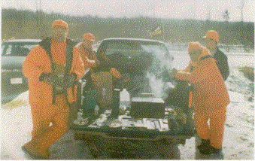
Packers Football and Crew – Opening Sunday Lunch
- 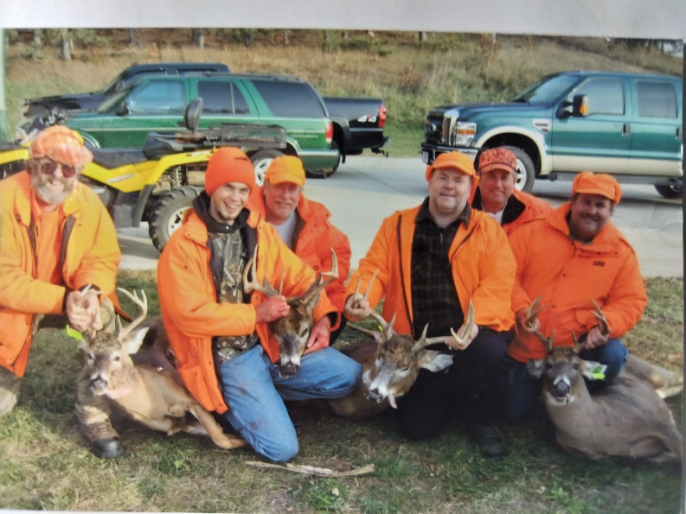
Osseo, WI Crew – 3 Shot & 1 Recovered Buck

- 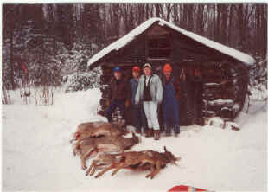
Drummond, WI Crew – 5 hunters & 4 deer

